Appendix 1. Ecosystem and Socioeconomic Profile of the Red King Crab stock in the Bristol Bay Report Card

Erin Fedewa, Kalei Shotwell, Abby Tyrell

Draft 2023



*With Contributions from:*

Kalei Shotwell, Abby Tyrell

# Current Year Update

The ecosystem and socioeconomic profile, or ESP, is a standardized framework for compiling and evaluating relevant stock-specific ecosystem and socioeconomic indicators and communicating linkages and potential drivers of the stock within the stock assessment process (Shotwell et al., 2023). The ESP process creates a traceable pathway from the initial development of indicators to management advice and serves as an on-ramp for developing ecosystem-linked stock assessments.

Please refer to the last full ESP, partial, and report card documents (*list references*) which are available within the Red King Crab stock assessment and fishery evaluation or SAFE reports for further information regarding the ecosystem and socioeconomic linkages for this stock.

## Management Considerations

Summary conclusions from ESP for ABC (risk table)

## Modeling Considerations

Summary of indicators with high importance in the Bayesian adaptive sampling routine and discussion of which indicators have had consistent high importance. List of research ecosystem model runs that are currently ongoing and potential for operational use in the future.

# Assessment

## Ecosystem and Socioeconomic Processes

One paragraph description of ecosystem and socioeconomic (if available) conceptual model(s)

## Indicator Suite

One paragraph description of LME level indicators relevant to stock (ESR summary)

### Ecosystem Indicators:

#### 1. Physical Indicators

1. Summer_Cold_Pool_SEBS_BBRKC_Survey: Summer cold pool extent (nmi) in Bristol Bay from the AFSC eastern Bering Sea bottom trawl survey
   * Contact: Erin Fedewa
   * Status and trends: **Information not present in database**
   * Factors influencing trends: **Information not present in database**
   * Implications: **Information not present in database**
2. Summer_Temperature_Bottom_BBRKC_Survey: Summer bottom temperatures in the BBRKC management area from the AFSC EBS bottom trawl survey
   * Contact: Erin Fedewa
   * Status and trends: **Information not present in database**
   * Factors influencing trends: **Information not present in database**
   * Implications: **Information not present in database**
3. Spring_pH_BBRKC_Model: Spring pH index in Bristol Bay crab management area from the Bering10K ROMS-NPZ model
   * Contact: Darren Pilcher
   * Status and trends: **Information not present in database**
   * Factors influencing trends: **Information not present in database**
   * Implications: **Information not present in database**
4. Spring_Corrosivity_Index_BBRKC_Model: Spring aragonite index in Bristol Bay crab management area from the Bering10K ROMS-NPZ model
   * Contact: Darren Pilcher
   * Status and trends: **Information not present in database**
   * Factors influencing trends: **Information not present in database**
   * Implications: **Information not present in database**
5. Summer_Wind_Stress_BBRKC_Satellite: Summer wind stress (m/s) in Bristol Bay crab management area from NOAA/NCDC blended winds and Metop-A ASCAT satellite
   * Contact: Kalei Shotwell
   * Status and trends: **Information not present in database**
   * Factors influencing trends: **Information not present in database**
   * Implications: **Information not present in database**

#### 2. Lower Trophic Indicators

1. Spring_Chlorophylla_Biomass_SEBS_Inner_Shelf_Satellite: Derived chlorophyll a concentration during spring in the southeastern Bering Sea inner shelf from the MODIS satellite
   * Contact: Matt Callahan
   * Status and trends: Low this year.
   * Factors influencing trends: See latest Ecosystem Status Report.
   * Implications: **Information not present in database**

#### 3. Upper Trophic Indicators

1. Summer_Sockeye_Salmon_Abundance_EBS_Survey: September juvenile sockeye salmon abundance in the EBS from the AFSC Bering Arctic Subarctic Integrated Survey
   * Contact: Ellen Yasumiishi
   * Status and trends: **Information not present in database**
   * Factors influencing trends: **Information not present in database**
   * Implications: **Information not present in database**
2. Summer_Pacific_Cod_Density_BBRKC_Survey: Summer Pacific cod biomass in Bristol Bay crab management area from the AFSC EBS bottom trawl survey
   * Contact: Erin Fedewa
   * Status and trends: **Information not present in database**
   * Factors influencing trends: **Information not present in database**
   * Implications: **Information not present in database**
3. Summer_Benthic_Invertebrate_Density_BBRKC_Survey: Summer benthic invertebrate biomass in Bristol Bay from the AFSC EBS bottom trawl survey
   * Contact: Erin Fedewa
   * Status and trends: **Information not present in database**
   * Factors influencing trends: **Information not present in database**
   * Implications: **Information not present in database**
4. Annual_Red_King_Crab_Recruit_Biomass_BBRKC_Model: Annual red king crab recruit biomass (110-134 mm CL) in Bristol Bay from the AFSC eastern Bering Sea bottom trawl survey
   * Contact: Jon Richar
   * Status and trends: **Information not present in database**
   * Factors influencing trends: **Information not present in database**
   * Implications: **Information not present in database**
5. Summer_Red_King_Crab_Male_Area_Occupied_BBRKC_Model: Summer mature male red king crab area occupied in Bristol Bay from the AFSC EBS bottom trawl survey
   * Contact: Erin Fedewa
   * Status and trends: **Information not present in database**
   * Factors influencing trends: **Information not present in database**
   * Implications: **Information not present in database**
6. Summer_Red_King_Crab_Female_Area_Occupied_BBRKC_Model: Summer mature female red king crab area occupied in Bristol Bay from the AFSC eastern Bering Sea bottom trawl survey
   * Contact: Erin Fedewa
   * Status and trends: **Information not present in database**
   * Factors influencing trends: **Information not present in database**
   * Implications: **Information not present in database**
7. Annual_Red_King_Crab_Catch_Distance_Shore_BBRKC_Fishery: Annual male red king crab catch distance from shore in Bristol Bay during the fishery
   * Contact: Leah Zacher
   * Status and trends: **Information not present in database**
   * Factors influencing trends: **Information not present in database**
   * Implications: **Information not present in database**

### Socioeconomic Indicators:

#### 1. Fishery Performance Indicators

1. Annual_Red_King_Crab_CPUE_BBRKC_Fishery: Annual catch-per-unit-effort (CPUE) (expressed as mean number of crabs per potlift) in the Bristol Bay red king crab fishery
   * Contact: Ben Daly
   * Status and trends: **Information not present in database**
   * Factors influencing trends: **Information not present in database**
   * Implications: **Information not present in database**
2. Annual_Red_King_Crab_Total_Potlift_BBRKC_Fishery: Annual total potlifts in the Bristol Bay red king crab fishery
   * Contact: Ben Daly
   * Status and trends: **Information not present in database**
   * Factors influencing trends: **Information not present in database**
   * Implications: **Information not present in database**
3. Annual_Red_King_Crab_Active_Vessels_BBRKC_Fishery: Annual number of active vessels in the Bristol Bay red king crab fishery
   * Contact: Brian Garber-Yonts
   * Status and trends: **Information not present in database**
   * Factors influencing trends: **Information not present in database**
   * Implications: **Information not present in database**
4. Annual_Red_King_Crab_Incidental_Catch_EBS_Fishery: Incidental catch biomass estimates of male Bristol Bay red king crab (tons) in trawl and fixed gear fisheries
   * Contact: Brian Garber-Yonts
   * Status and trends: **Information not present in database**
   * Factors influencing trends: **Information not present in database**
   * Implications: **Information not present in database**

#### 2. Economic Indicators

1. Annual_Red_King_Crab_TAC_Utilization_BBRKC_Fishery: Percentage of annual Bristol Bay red king crab total allowable catch that was harvested by active vessels
   * Contact: Brian Garber-Yonts
   * Status and trends: **Information not present in database**
   * Factors influencing trends: **Information not present in database**
   * Implications: **Information not present in database**
2. Annual_Red_King_Crab_Exvessel_Value_BBRKC_Fishery: Annual red king crab ex-vessel value of the Bristol Bay red king crab fishery landings
   * Contact: Brian Garber-Yonts
   * Status and trends: **Information not present in database**
   * Factors influencing trends: **Information not present in database**
   * Implications: **Information not present in database**
3. Annual_Red_King_Crab_Exvessel_Price_BBRKC_Fishery: Annual red king crab ex-vessel price per pound of the Bristol Bay red king crab fishery
   * Contact: Brian Garber-Yonts
   * Status and trends: **Information not present in database**
   * Factors influencing trends: **Information not present in database**
   * Implications: **Information not present in database**
4. Annual_Red_King_Crab_Exvessel_Revenue_Share_BBRKC_Fishery: Annual red king crab ex-vessel revenue share (expressed as percent of total ex-vessel revenue) of the Bristol Bay red king crab fishery
   * Contact: Brian Garber-Yonts
   * Status and trends: **Information not present in database**
   * Factors influencing trends: **Information not present in database**
   * Implications: **Information not present in database**

#### 3. Community Indicators

## Indicator Monitoring Analysis

References for statistical tests for monitoring indicator suite by stage where relevant

### Beginning Stage: Traffic Light Test

One paragraph summary of indicator status and trends over time and last five years trend Report scores by category (if applicable) and overall ecosystem and socioeconomic indicators.

### Intermediate Stage: Importance Test

One paragraph summary of importance results with analysis of highly explanatory variables for stock assessment input of interest (e.g., recruitment estimates)

### Advanced Stage: Research Model Test

Update on ecosystem linked model in development and link to relevant literature or report on model

# Data Gaps and Future Research Priorities

Copy from full ESP

# Tables

Table 1: First stage ecosystem indicator analysis for Red King Crab, including indicator title and the indicator status of the last five years. The indicator status is designated with text, (greater than = "high", less than = "low", or within 1 standard deviation = "neutral" of long-term mean). Fill color of the cell is based on the sign of the anticipated relationship between the indicator and sablefish (blue = good conditions for sablefish, red = poor conditions, white = average conditions). A gray fill and text = "missing" will appear if there were no data for that year.

| **Indicator category** | **Indicator** | **2019 Status** | **2020 Status** | **2021 Status** | **2022 Status** | **2023 Status** |
| --- | --- | --- | --- | --- | --- | --- |
| Larval | Winter Spring Arctic Oscillation Index Model | neutral | *high* | neutral | neutral | neutral |
| Physical | Summer Cold Pool SEBS BBRKC Survey | **low** | NA | **low** | neutral | neutral |
| Summer Temperature Bottom BBRKC Survey | *high* | NA | neutral | neutral | neutral |
| Spring pH BBRKC Model | **low** | **low** | **low** | **low** | **low** |
| Summer Wind Stress BBRKC Satellite | **high** | neutral | **high** | neutral | neutral |
| Lower Trophic | Spring Chlorophylla Biomass SEBS Inner Shelf Satellite | neutral | neutral | neutral | **low** | **low** |
| Upper Trophic | Summer Sockeye Salmon Abundance EBS Survey | NA | NA | NA | **high** | NA |
| Summer Pacific Cod Density BBRKC Survey | *low* | NA | neutral | neutral | NA |
| Summer Benthic Invertebrate Density BBRKC Survey | neutral | NA | neutral | neutral | NA |
| Summer Red King Crab Male Area Occupied BBRKC Model | *high* | NA | neutral | *high* | neutral |
| Summer Red King Crab Female Area Occupied BBRKC Model | *high* | NA | *high* | neutral | neutral |
| Annual Red King Crab Catch Distance Shore BBRKC Fishery | *high* | neutral | neutral | neutral | NA |

Table 2: First stage socioeconomic indicator analysis for Red King Crab, including indicator title and the indicator status of the last five years. The indicator status is designated with text, (greater than = "high", less than = "low", or within 1 standard deviation = "neutral" of long-term mean). Fill color of the cell is based on the sign of the anticipated relationship between the indicator and sablefish (blue = good conditions for sablefish, red = poor conditions, white = average conditions). A gray fill and text = "missing" will appear if there were no data for that year.

| **Indicator category** | **Indicator** | **2019 Status** | **2020 Status** | **2021 Status** | **2022 Status** | **2023 Status** |
| --- | --- | --- | --- | --- | --- | --- |
| Fishery Performance | Annual Red King Crab CPUE BBRKC Fishery | neutral | neutral | NA | NA | NA |
| Annual Red King Crab Total Potlift BBRKC Fishery | neutral | low | NA | NA | NA |
| Annual Red King Crab Active Vessels BBRKC Fishery | neutral | neutral | low | NA | low |
| Annual Red King Crab Incidental Catch EBS Fishery | neutral | neutral | neutral | neutral | neutral |
| Economic | Annual Red King Crab TAC Utilization BBRKC Fishery | neutral | neutral | NA | NA | NA |
| Annual Red King Crab Exvessel Value BBRKC Fishery | low | low | NA | NA | low |
| Annual Red King Crab Exvessel Price BBRKC Fishery | high | high | NA | NA | high |
| Annual Red King Crab Exvessel Revenue Share BBRKC Fishery | neutral | neutral | NA | NA | high |

# Figures



##### Figure 1. Life history conceptual model for Red King Crab summarizing ecological information and key ecosystem processes affecting survival by life history stage. Red text means increases in process negatively affect survival, while blue text means increases in process positively affect survival.

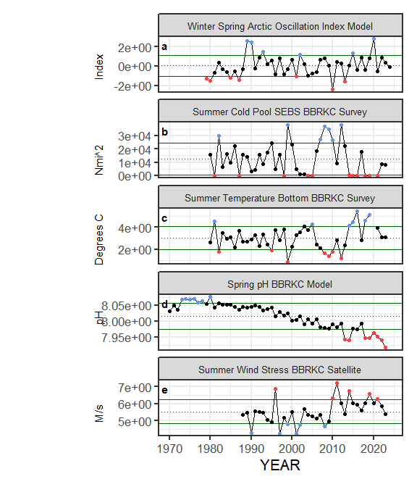

##### Figure ??. Selected ecosystem indicators for Red King Crab with time series ranging from 1966 – present. Upper and lower solid green horizontal lines are plus and minus one standard deviation of the time series mean. Dotted green horizontal line is the mean of the time series.

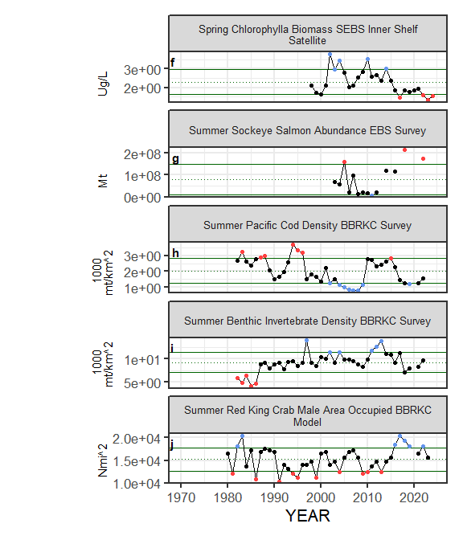

##### Figure ??. Selected ecosystem indicators for Red King Crab with time series ranging from 1966 – present. Upper and lower solid green horizontal lines are plus and minus one standard deviation of the time series mean. Dotted green horizontal line is the mean of the time series.

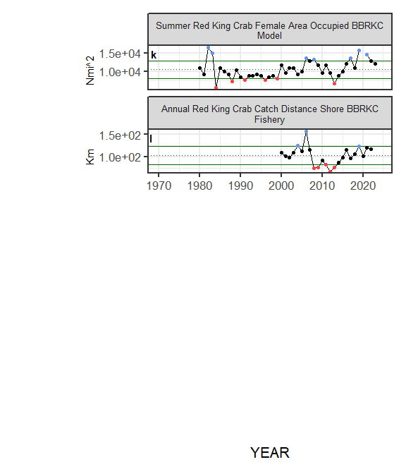

##### Figure ??. Selected ecosystem indicators for Red King Crab with time series ranging from 1966 – present. Upper and lower solid green horizontal lines are plus and minus one standard deviation of the time series mean. Dotted green horizontal line is the mean of the time series.

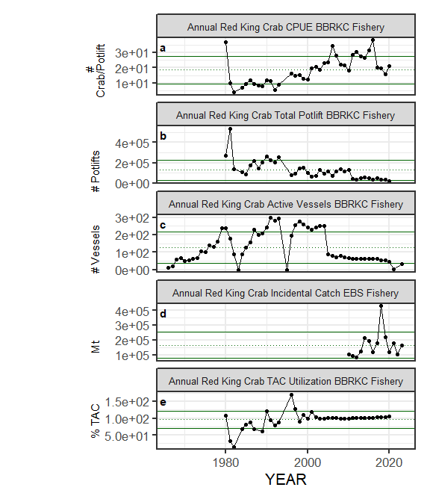

##### Figure ??. Selected socioeconomic indicators for Red King Crab with time series ranging from 1966 – present. Upper and lower solid green horizontal lines are plus and minus one standard deviation of the time series mean. Dotted green horizontal line is the mean of the time series.

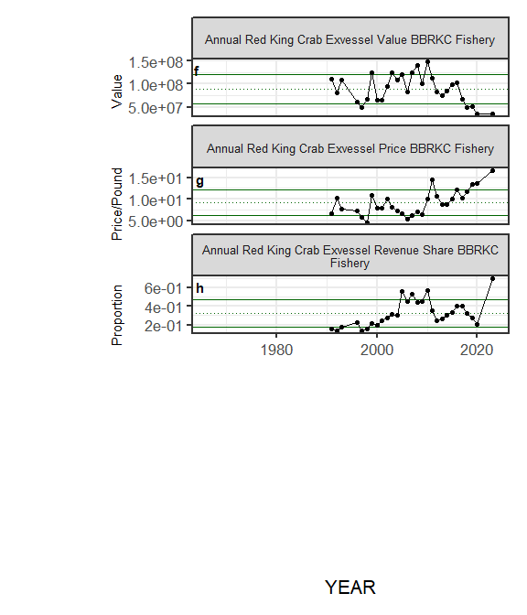

##### Figure ??. Selected socioeconomic indicators for Red King Crab with time series ranging from 1966 – present. Upper and lower solid green horizontal lines are plus and minus one standard deviation of the time series mean. Dotted green horizontal line is the mean of the time series.

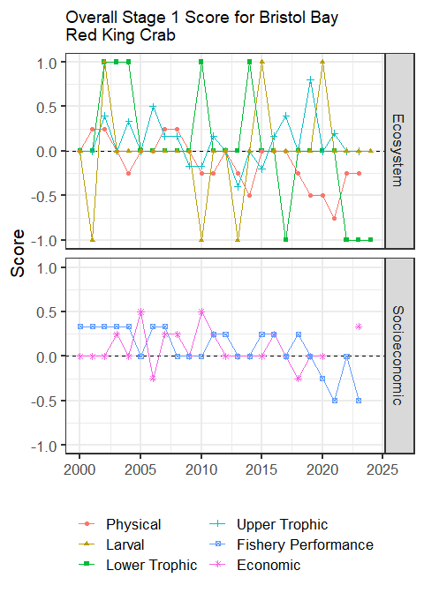

##### Figure 7. Simple traffic light score for overall ecosystem and socioeconomic categories from 2000 to present.



##### Figure 8. Bayesian adaptive sampling output showing (a) standardized covariates prior to subsetting and (b) the mean relationship and uncertainty (95% confidence intervals) with log Red King Crab recruitment, in each estimated effect (left bottom graph), and marginal inclusion probabilities (right bottom graph) for each predictor variable of the subsetted covariate set